**Linking Species Functional Roles To Their Network Roles**

Camille COUX1, Romina RADER2, Ignasi BARTOMEUS3, Jason M. TYLIANAKIS1,4

1Centre for Integrative Ecology, School of Biological Sciences, University of Canterbury, Private Bag 4800, Christchurch 8140, New Zealand

2Ecosystem Management, School of Environment and Rural Sciences, University of New England, Armidale, NSW, Australia

3Estación Biológica de Doñana (EBD-CSIC), Dpto. Ecología Integrativa, Avda. Américo Vespucio s/n

Isla de la Cartuja 41092, Sevilla, Spain

4Department of Life Sciences, Imperial College London, Silwood Park Campus, Buckhurst Road, Ascot, Berkshire SL5 7PY, UK

SHORT RUNNING TITLE (45 characters incl. spaces): Linking species functional and network roles

KEY WORDS: Biodiversity, ecosystem functioning, mutualistic network, interaction, web, stability, resilience

TYPE OF ARTICLE: Letters

WORD COUNT: Abstract: 150; Main text: 5243; number of references: 50

5 figures, 1 Table, 1 Supporting Information.

STATEMENT OF AUTHORSHIP

CC wrote the manuscript and conducted analyses with inputs from JT and IB. RR designed and conducted the field study with assistance from JT. RR and IB compiled the trait data. All authors conceptualised the study and commented on the manuscript. JT secured funding.

CORRESPONDING AUTHOR:

Camille Coux

Centre for Integrative Ecology, School of Biological Sciences, University of Canterbury, Private Bag 4800, Christchurch 8140, New Zealand

Email: camille.coux@orange.fr

Cell phone +64-22-186-5969

Fax +64-3-364-2590

ABSTRACT

Species roles in ecological networks combine to generate their architecture, which contributes to their stability. Species trait diversity also affects ecosystem functioning and resilience, yet it remains unknown whether species’ contributions to functional diversity relate to their network roles. Here we use 21 empirical pollen transport networks to characterise this relationship. We found that, apart from a few abundant species, pollinators with original traits either had few interaction partners or interacted most frequently with a subset of these partners. This suggests that narrowing of interactions to a subset of the plant community accompanies pollinator niche specialisation, congruent with our hypothesised trade-off between having unique traits vs. being able to interact with many mutualist partners. Conversely, these effects were not detected in plants, potentially because key aspects of their flowering traits are conserved at a family level. Relating functional and network roles can provide further insight into mechanisms underlying ecosystem functioning.

INTRODUCTION

The role biodiversity plays in ecosystem functioning has received much attention (Hooper *et al.* 2005), motivated by increasing species extinction rates (Pimm *et al.* 2014) and potential loss of ecosystem services (Thompson & Starzomski 2007). Early findings that the positive biodiversity-ecosystem functioning relationship (e.g. Tilman *et al.* 1996) was not universal (Thompson & Starzomski 2007) drew attention to the redundancy of functional traits across species (Walker 1991). The diversity of traits (i.e. ‘functional diversity’; Lavorel & Garnier 2002) has become a focus of considerable research, as it can predict the rates of ecosystem processes more accurately than does species richness (Reiss *et al.* 2009; Gagic *et al.* 2015), and differences in the redundancy of traits within a community can yield various biodiversity-ecosystem functioning relationships (e.g. saturating or sigmoidal).

Species’ traits define their functional role by accounting for the morphological, physiological and phenotypic features that affect ecosystem processes or respond to the environment (Lavorel & Garnier 2002)(Lavorel & Garnier 2002). The originality and uniqueness of a species’ traits relative to others in the community define its functional role and contribution to the community functional diversity, i.e. the total diversity of traits displayed by all species (and which reflects a community’s functional “capacity” (Laliberté & Legendre 2010) . The loss of species following land-use change has been shown to reduce this functional diversity (Laliberté *et al.* 2010; Rader *et al.* 2014) and alter ecosystem functioning and services (Larsen *et al.* 2005). Moreover, these losses may non-randomly select certain species based on their ‘response’ traits (Larsen *et al.* 2005), and the interplay of response and effect traits can produce non-random functional changes following environmental change (Lavorel & Garnier 2002). We do not attempt here to infer response and effect trait correlations *a priori,* but rather seek to understand how known response and effect traits will also affect the propensity of species to interact, and thereby generate changes to interaction networks.

Indeed, species traits are also known to influence ecological interactions to the point where whole interaction-network topology can be predicted (Eklöf *et al.* 2013), and this topology can have important impacts on resilience (Gao *et al.* 2016). For example, Montoya *et al.* (2015) assigned species to functional groups based on their trophic function (e.g. pollination or decomposition) and found that network modularity favoured higher functional group diversity. Furthermore, a species’ function within a community has also been defined relative to the traits of the species with which it interacts (Dehling *et al.* 2016), based on the idea that interactions mediate morphological trait-matching. Thus, the global structure of ecological networks, as well as the relative arrangement of each species’ interactions that define their network roles, may capture important elements not only of species diversity, but also functional diversity (Poisot *et al.* 2013).

However, these functional and network roles may place different constraints on species traits, as the benefits that emerge from functional originality could oppose those arising from acquiring mutualistic interactions. In fact, the benefits of reduced competition that emerge through niche partitioning and drive the functional diversification of species (Grime 2001) may reinforce individual mutualisms through co-specialisations mediated by the cost-benefit balance for the involved partners. Yet, this process may oppose the preservation of many mutualistic interactions in which species are involved, and which constrain their traits to match those of a range of partners, thereby potentially favouring interaction generalism (Fontaine *et al.* 2009). We therefore hypothesise a trade-off between species traits being sufficiently unique to exploit different resources, while remaining similar enough to maintain interactions with a higher number of mutualistic partners. In addition, species relative abundances in a community may further complicate this trade-off, e.g. by affecting species functional diversification through intra- and inter-specific competition (Chesson 2000), as well as the partner selection process, which is likely density-dependent (Fort *et al.* 2015). Despite the fact that a network approach could encapsulate these previous trade-offs and thereby improve our understanding of their relationships, it remains unknown whether functional roles of species are related to their network roles (Reiss *et al.* 2009; Thompson *et al.* 2012).

Here we use empirical data from 21 pollen transport networks to characterise the network roles of plant and pollinator species, and investigate whether these are linked to their functional roles. Specifically, we test whether the position of a species in the network relates to its contribution to community functional diversity (i.e. the uniqueness of its traits). We hypothesise that a species’ functional originality will be positively related to its degree of resource specialisation, because specialists should have evolved original traits to better access a single resource, whereas generalists should have average, widespread trait values that do not limit their ability to interact with other species, even if generalist species could also be rare.

METHODS.

*Site description and experimental design*

Six replicates of each of four land-use types (in decreasing order of intensity): rotational cropping, dairy farms, blackcurrant orchards and native gardens were sampled in the Canterbury plains region, a highly modified agricultural landscape in the South Island of New Zealand (see Rader et al. 2014 for site details). We chose this dataset because the gradient of land-use intensity has been shown to generate a decline in community functional diversity (Rader *et al.* 2014), thereby ensuring that we had a broad range in this predictor variable to test whether it was related to the pollen transport network structure.

*Sampling methods*

At each of the 24 sites, insect pollinators were trapped for five days per month from November 2008 to 2009 using flight-intercept and pan traps. The two trapping methods were used to maximize the diversity and sample size of insects captured. At the end of each day, insects were removed and trapping materials replenished (see Rader *et al.* 2014 for further details of trapping methods). Insects were sorted to species (Table S1) using existing collections, identification keys (Donovan 2007; Landcare Research, 2013) and assistance from expert taxonomists. The pollen found on the underside of pollinator species was sampled by pressing insects onto a cube of gelatine–fuchsin (c. 3 mm × 3 mm × 3 mm) and slide mounted. Pollen grains were then counted manually under a microscope using a pollen library of plant specimens collected at each site at the time of sampling (as in Rader *et al.* 2011, see Appendix 1 in S.I. for more details on pollen identification and quantification, and Table S2 for a list of plant species). Data were pooled across trap types (pan and flight-intercept traps) and time (i.e. monthly trap collections for 1 year) to achieve the best resolution possible when identifying interactions among species. Of the initial 24 sites, 3 communities were excluded due to their small sample sizes. Voucher specimens are housed at the New Zealand Institute for Plant and Food Research in Lincoln, New Zealand.

*Trait measurement*

Pollinator and plant traits, as well as some species-level behavioural responses to changing environments comprising many traits, were compiled using existing published and unpublished datasets from the Canterbury region (Tables S3, S4, S.I.). In some cases, the traits are fixed attributes of a species, whereas others are continuous and vary among individuals within species. In the latter case, we used mean values from ten representative specimens (Table S3) (Rader *et al.* 2014), because our aim was to relate species traits with their roles in the interaction network, the nodes of which represent species, rather than individuals.

We recorded two traits pertaining to pollinator body size (length and width), which is known both to constrain the breadth of species’ trophic niches and correlate negatively with reproductive rate (Stang *et al.* 2006) and also to moderate pollination efficiency (e.g., larger insects are hypothesised to have a higher pollen carrying capacity than smaller ones, Larsen *et al.* 2005; Hoehn *et al.* 2008). Likewise, the time spent on the inflorescence (in seconds) is a trait that could simultaneously influence pollination efficiency (Hoehn *et al.* 2008) and be an expression of a response to changes in resource quality (according to optimal foraging theory, Pyke 1978). We also estimated phenology using time of daily abundance peak as well as month of seasonal abundance peak for each insect species during the sampling season (i.e. daily and seasonal activity), as this will determine the amplitude of the match with the plants that flower at a given period, and phenology may respond to environmental changes such as climate (Bartomeus *et al.* 2011). Foraging behaviour can underpin pollination success, hence we recorded the diet preferences of adults (proportions of their diet made up of nectar versus pollen based on field observations; Rader *et al.* 2014) and the type of carrying structure used for pollen transport (corbicula, scopa or none). Moreover, diet preferences of larvae (whether their diet included nectar, plant matter, carrion, dung, parasitism of other insects, and/or predation of other insects) and nesting behaviour (social vs. solitary) are traits that have been shown to influence species responses to environmental changes such as land use or habitat fragmentation (Williams *et al.* 2010). Because we had no *a priori* reason to weight some traits more than others, we considered each trait to be of equal importance in its ability to influence a species’ functional niche. However because body length and width are non-independent features relating to body size, we grouped them together by assigning them a weight of 1/2 throughout the analyses so that the ‘body size’ trait had an equal weight to all the other measured traits. For the same reason, the use of each kind of larval food resource was given a fractional weighting so that all components of larval diet summed to a single trait. See Table S3 in Appendix 1 of the S.I. for a summary of pollinator traits.

For the plant community, we recorded morphological traits that pertained to plant type (grass, herb, shrub or tree), inflorescence morphology (number of flowers per inflorescence, flower symmetry e.g., actinomorphic or zygomorphic; branching organisation type e.g., spike, catkin, umbel, capitulum or other), pollen and nectar access, and physiological characteristics (life span, sex, fragrance, amount of nectar). We also kept a phenological record when flowering of each plant occurred throughout the sampling season (presence/absence of flowers spanning spring, summer, fall and winter), and as for pollinator body size, we gave each season a weight of 0.25 in order to obtain one final ‘season’ trait (see Table S4, Appendix 1 of the S.I. for a record of plant traits).

The selected traits reflect the capacity for plants to adapt to changing environments as well as their availability and attractiveness for pollinators (“pollination syndrome” traits, Fenster *et al.* 2004).

*Species functional originality and uniqueness*

For a given community, functional diversity is defined by the matrix comprising the trait attributes of every species. These are used to calculate the coordinates of the species in a multivariate space, where each trait corresponds to an axis (Petchey & Gaston 2006; Laliberté & Legendre 2010). The functional niche (or phenotypic range) of the community depends both on the number of traits (i.e. axes, which were constant in each of our networks) and on the range of trait values. The boundaries of this functional niche are delimited by species with the most extreme trait values, and the centroid corresponds to the ‘average’ trait values of all species of the community. We calculated two different metrics: functional originality and uniqueness. Functional originality is the distance of a species from that centroid, i.e. how its traits differ from the community trait average (Laliberté & Legendre 2010, Buisson *et al.* 2013) within a given community. Functional uniqueness corresponds to the distance of a species to its nearest neighbour. Species with a similar combination of trait values are located closer together in trait space, and therefore the distance of a species to its nearest neighbour is a good measure of its functional uniqueness (conceptually, it is the opposite of functional redundancy, Walker 1991; Buisson *et al.* 2013). These two measures could at first glance seem related, but in fact, two species can simultaneously be functionally original by having a combination of traits differing from that of the community average, and still not be unique if they are similar to each other in their trait combinations. This distinction would be particularly apparent if species formed clusters in trait space, but these clusters were all distant from the centroid. Figure 1 is a 2-dimensional representation of this multivariate trait space, where species are represented by points.

Species’ relative abundances can be used to weight the average trait values when calculating the functional trait space, thereby shifting the position of the centroid towards the most abundant species (the red cross in Figure 1 is closer to larger points corresponding to abundant species). In this quantitative measure of functional originality (Laliberté & Legendre 2010), rarer species displaying different trait attributes contribute more to extending community diversity than do abundant species, because that combination of traits itself is rarer in the community than if it had belonged to an abundant species. In contrast, when only qualitative (species presence/absence) data are used, the centroid is the unweighted average of community trait values, which sets each species on an even ground and prevents abundant species with trait values that deviate from those of other species from appearing less ‘original’ simply because they comprise a large proportion of the individuals in the community. The coordinates of each species however remain identical whether the community average is weighted or not; hence the measure of functional uniqueness is independent of species’ relative abundances and only changes with species presences or absences from a community.

In our study, we used the weighted measure of originality for the pollinator community, for which we had independent measures of abundances based on the number of insects caught in the traps. This corresponds to a trait-centred approach that quantifies the occurrence of traits in a community and fully endorses the underlying aim of functional diversity, which is to focus on traits rather than species to quantify biodiversity and ecological processes (Mouillot *et al.* 2005; Petchey & Gaston 2006). We did not have independent measures of plant abundances (see below), and we therefore used the unweighted measure of plant functional originality, which in comparison, corresponds to a species-centred approach based on the number of species characterised by that trait. As species form the nodes of our networks, they remain an important functional unit of our framework. We provide the unweighted version of the analysis for the pollinator community for comparison in Appendix 2, S.I.

We used the functional originality and uniqueness of each species as measures of their functional role. With the traits measured for pollinator and plant species across the 21 out of the initial 24 sites, we calculated sets of coordinates for each species and the centroid for each site using a Principal Coordinates Analysis (PCoA), as used in other studies of functional diversity (e.g. Buisson *et al.* 2013; Mouillot *et al.* 2013b; Gagic *et al.* 2015). Even though species’ coordinates were fixed across sites, changes in species composition, as well as in pollinator relative abundances, shifted the position of the centroid in each plant and pollinator community. This yielded different site-specific measures of species originality and uniqueness, thereby defining their functional role within each site. This approach allowed us to provide a measure of relative functional diversity that was scaled and comparable across sites, because we essentially defined a maximal functional diversity (by fixing the multivariate space of all species) against which to compare each local community’s functional properties. In this sense, a species can only be ‘original’ or ‘unique’ when compared with others in its community, such that originality is not a fixed trait of a species but rather depends on its community context. Therefore, functional originality is only conserved across different communities if a species has a combination of traits so different from all the other species that it is seldom average, or if the composition of other species is conserved. The primary aim of this approach was thus to obtain a measure of a given species’ contribution to functional diversity, relative to its community context, rather than determining which particular traits were most important in driving the functional roles of species in the networks (but see Appendix 3 of the S.I. for an evaluation of the most important traits in our communities).

Each trait was standardised (mean = 0, variance = 1) for the estimation of functional originality, and non-numerical traits were standardised according to Gower’s (1971) standardisation by range prior to their conversion into dissimilarity matrices for the computation of the PCoA. These calculations were realised using version 1.0-12 of the dbFD function from the FD package (Laliberté & Legendre 2010; Laliberté & Shipley 2011); R version 3.2.2 (2015-08-14); analysis code can be found in Appendix 4, and is accessible online at: https://github.com/CamilleCoux/Ntw_FD_roles).

*Interaction networks*

Two methods are commonly used to generate plant-pollinator interaction networks; (i) pollinator visitation surveys conducted on focal plants and (ii) pollen transport networks. Visitation surveys generally comprise high proportions of pollinator species linked to a single plant species, thus this approach may overestimate ecological specialization (Bosch *et al.* 2009). In contrast, pollen transport networks often reveal additional plant-pollinator links (that would otherwise have gone undetected) due to the physical presence of pollen on a pollinator. Yet, this approach may underestimate ecological specialization and be influenced by pollinator grooming behaviour and/or body size (Harder 1990). Here, we used the records we obtained of pollinators and the pollen they carried to construct weighted pollination networks where we quantified the interaction links by recording the number of pollinator individuals of species *i* carrying pollen of a given plant species *j*. From a pollinator’s perspective, this measures the frequency with which a plant species is used; from a plant’s perspective, it is related to pollinator visitation frequency, but does not make any assumptions about the value of carrying more pollen.

*Network structure description*

To evaluate the role occupied by each species in each pollination network, we calculated a set of indices that described i) each species’ potential range of interaction partners, and ii) any observed relative preference for certain species within its range of potential partners. i) normalised degree (ND) is the sum of interactions per species (normalised within networks to control for variation in network size), and is a classic descriptor of a node’s connectedness, which also correlates with many other aspects of network topology (Gómez & Perfectti 2012). ii) Specificity (HS), as measured by Shannon’s entropy divided by the number of partners, measures the specialisation of species *i* on *j*, such that the evenness of a species’ interactions are quantified within its range of partners. The specificity of species *i* ranges between 1 for a perfect specialist and 0 for a perfect generalist. Normalised degree is a binary metric; specificity was calculated based on quantitative (i.e. weighted) interactions (calculation for ND : ‘specieslevel’ function, bipartite package 2.04; for HS: ‘getspe’ function, package ESM 2.0.3-02, Poisot 2011). Combined, these indices describe each species’ connectedness and their relative use of each of their interaction partners. Thus, they describe many crucial aspects of a species’ role in a network, and also correlate strongly with other species-level network indices, which are mostly variations on the number of interaction partners (resource range, species strength, effective partners, nestedness rank) or generalism/specialism (node specialisation, proportional generality, proportional similarity; Dormann 2011).

*Linking species traits with network roles and relative abundances*

For the pollinator community, we used linear mixed effects models (LMMs) to test whether the network role of a pollinator species, as defined by its normalised degree (ND) or specificity (HS), was predicted by its functional role, defined as its functional originality (i.e., its distance from the centroid in multidimensional niche space) and uniqueness (its distance to its nearest neighbour). For each model with either ND or HS as response variable, we used weighted originality or uniqueness as fixed effects in separate models (see Appendix 5 of S.I. for correlation structures between predictor variables), which yielded a total of 4 different models. A corresponding set of models was generated for the plant community, except that we used the unweighted measure of originality as plant abundances were not measured. We do not explicitly compare pollinators with plants, so this difference could not confound our results for each level.

In addition to the measures of a species’ functional role, we also included pollinator abundance in both pollinator and plant models as fixed covariates to predict network role. Not only is pollinator abundance a measure of sample size, but the abundance of a species is also an important part of its ecology and can determine its functional importance in the community, so it could be one of the mechanisms explaining the correlations between network and functional roles. One of the pollinator species, *Lasioglossum sordidum*, was found to have an unusually high abundance in the first site. After calculating its leverage, we considered it as a statistical outlier (Crawley 2007). We thus set its abundance to 0 and removed it from the analysis such that other species of that community remained unchanged by this removal (see Appendix 2, S.I. for more details, and results of the analysis comprising the outlier). This did not qualitatively affect the results pertaining to originality or uniqueness.

Although ND and HS metrics are both normalised to control for network size, we included the product of the number of pollinator species by the number of plant species as a measure of network size in our models to control for these potential artefacts. We tested for two-way interactions both between functional role and pollinator abundance (in the pollinator models), and functional role and network size (in all models) to control for any interference of these effects with either species originality or uniqueness. Finally, to control for the non-independence between species from each network, we included site as a random effect in each model. We also tested a final set of models in which unweighted pollinator originality is used (Appendix 2, S.I.).

Best-fitting models were obtained after testing every possible subset of these models (with main effects and interactions removed, adhering to the principle of marginality) by minimising Akaike’s Information Criterion (AIC). In cases where several competing models had a difference of less than 2 in AIC scores, which suggested their fit were not statistically different, we applied model averaging techniques (‘model.avg’ function MuMIn package 1.15.1, (Barton 2015). The results presented are those of conditional averages.

All models were computed using the ‘lme’ function (nlme package 3.1-122, Pinheiro *et al.* 2014).

RESULTS

We obtained pollination networks ranging from 4 to 23 species, comprising 3 to 99 realised links, which represents connectance values from 0.22 to 0.87. The mean normalised degree for the pollinator community across all networks was equal to 0.42; that of plants 0.45. For specificity, pollinators showed an average of 0.58 and a higher frequency of highly specific species focussing on one plant. This effect was enhanced among the plants, which had an average specificity of 0.72.

The relationship between pollinator normalised degree and weighted originality was averaged across 2 best-fitting models and revealed a significant negative effect of originality on a pollinator’s normalised degree, indicating that pollinator species with an original combination of traits relative to the community average tended to have fewer interactions (Table 1a, Figure 1). However, a positive interaction effect between abundance and weighted originality revealed that this effect was compensated for in the few most abundant pollinator species with original traits (Figure 2, Table 1a). In addition, we note here that this interaction effect was stronger than the weak, negative main effect of abundance, such that abundant pollinators generally had more interactions than rare ones, as would be expected based on sampling effort.

The relationship between pollinator specificity and weighted originality was also averaged across the 2 best-fitting models, and indicated a strong positive relationship. This suggested that pollinators with unique traits that differed from the rest of the community focused preferentially on a limited subset of their partners (Table 1b). As with normalised degree, there was also a significant interaction effect between originality and abundance that moderated this relationship, as the most abundant pollinators showed less specificity than those that had more average traits (Figure 3, Table 1b). However, as in the previous model, this interaction effect was stronger than the main effect of abundance, and therefore abundant pollinators were overall less specific than rare pollinators.

When we examined functional uniqueness as a fixed effect, we found that the average of the 2 best-fitting models contained a significant positive relationship with normalised degree, indicating that species with unique trait combinations had more interaction partners than species that were functionally similar (Table 1c). Although abundant pollinators had more interaction partners (Table 1c), as would be expected from greater sampling effort, there was no significant interaction between abundance and uniqueness.

Finally, the three averaged best-fitting models considering the effects of pollinator uniqueness, abundance and network size on pollinator specificity revealed a negative correlation between uniqueness and specificity, indicating that pollinators with unique trait combinations interacted more evenly with their plant partners (Table 1d, Figure 4).

Contrasting with the pollinator community, we did not find any significant relationships between plant normalised degree and species’ unweighted originality (P=0.608) or uniqueness (P=0.627). The only significant effects concerned a negative correlation between normalised degree and network size (coef. = -0.004, p=0.010), simply indicating that plants interacted on average with proportionately fewer pollinators in larger networks. Furthermore, we did not find any significant effect of originality (P=0.53) or uniqueness (P=0.472) on plant specificity. This suggests that neither the number of interactions with pollinator partners, nor the evenness in a plant’s interactions with its pollinators was influenced by how different the traits of a plant species were compared to the community average or to its most functionally similar plant species counterpart.

DISCUSSION

We have found that the role of a pollinator in the interaction network was correlated with its functional role, as defined by its functional originality and functional uniqueness compared with other pollinator species present in the community. Our finding that species with trait profiles that differed from the community average had fewer interaction partners and/or interacted most frequently with only a subset of these (Table 1a, 1b) is congruent with our hypothesised trade-off between having unique traits to avoid competition but needing to retain interaction partners. This suggests that the functional specialisation of pollinators is reflected by the narrowing down of their interactions to a subset of the plant community, possibly as a means to avoid competition between pollinators for shared plant resources (Vamosi *et al.* 2014).

This benefit of reduced competition was most evident when we examined a pollinator’s trait difference from its functionally most similar counterpart in a given community (i.e. uniqueness). In this case, the most functionally unique pollinators were those with the most interaction partners. This suggests that competition for access to a shared resource is likely to be more intense between two redundant species than between species that are functionally unique, and further satisfies the idea that the number of interactions of a pollinator depends on its functional status in the community. Thus, species’ contributions to community functional diversity were correlated with a combination of network metrics that captured both the range of interaction partners and the quantitative preferential focus on particular partners.

Although functional roles were associated with certain network roles for pollinator species, this relationship did not hold for plants. This absence suggests that original plant traits (particularly with respect to floral structures and resource allocation to flowering) do not necessarily act as barriers to interaction with pollinators, which may be partly due to the conservation of many categorical traits (such as flower symmetry, inflorescence type) at the family level. Furthermore, this depicts a more homogenous distribution of species in the trait space, where differences in plant originality and uniqueness are less important than in the pollinator community, and are rather levelled out by the use of presence/absence data for plant originality values.

In contrast, pollinator’s relative abundances were associated with higher normalised degree and lower specificity, which is to be expected given that abundant species have a larger probability to randomly interact than rare species (Fort *et al.* 2015). Interestingly, there was a recurrent interaction effect between abundance and pollinator originality, whereby the relationships between the latter and normalised degree or specificity were reversed for abundant species. Therefore, the trade-off between originality and interaction partner diversity may not apply to species that are successful enough to be abundant, either because or in spite of their unique trait combinations. This was frequently the case for certain pollinator species, such as *Apis mellifera* or *Lasioglossum sordidum*, which appeared to have succeeded in being functionally original and retaining many interaction partners in most of the communities in which they were recorded (Figure 5).

Most other species, however, were not as consistent in their network or functional roles across sites (Figure 5; see also Figure S4, Appendix 6, S.I.). This context-dependency in the originality of any given species suggests that the correlation between functional and network roles across sites are not driven simply by the identity of a few key species with extreme traits that interact in a certain way. Similarly, important variations in interaction turnover can also occur through time, and specialisation can be highly variable (Brosi & Briggs 2013), which suggests the importance of context-dependency in network roles. In an evolutionary sense, this suggests that it may be difficult for a species to evolve traits that are novel across its entire spatial and temporal range of community contexts. Furthermore, as our communities were sampled over an anthropogenic gradient (Rader *et al.* 2014), it is likely that the importance of functions fulfilled by specific traits do not occupy the same rank in different sites, which may be reflected here. Moreover, the spatial and temporal scales of differing land uses would likely be sufficient to allow trait-based competitive exclusion of species, but not the evolution of novel traits.

Our results provide an important step forward in merging the fields of interaction networks with the functional diversity framework (Thompson *et al.* 2012; Poisot *et al.* 2013). Recently, Eklöf *et al.* (2013) found that surprisingly few traits (< 10, similar to the number of traits used here) were needed to predict interactions in different types of ecological networks. This linking of traits with whole-network structure complements work linking network structure to ecosystem functioning (e.g, Peralta *et al.* 2014) and the importance of functional trait diversity for ecosystem functioning and resilience (Mouillot *et al.* 2013b). Our finding that there is a context-dependent relation between network roles and trait originality of species opens up possibilities to predict the functional responses of communities to realistic extinction sequences beyond simple trait-matching mechanisms. For example, recent studies have linked the role of species in interaction networks to their extinction risk, concluding that low interaction degree and rarity characterised species and interactions most prone to extinction (Aizen *et al.* 2012). Mouillot *et al.* (2013) further found that rare species displayed the least redundant functions. Combined with our findings, these results suggest that the order in which species go extinct from networks may generate a more rapid decline in functional diversity than would be expected if species went extinct at random, as has been observed in highly-modified land uses (Rader *et al.* 2014). This merging of network and functional diversity approaches highlights the trade-offs associated with niche differentiation within interacting communities, and links species interactions with the response of ecosystem functioning to a changing environment.

ACKNOWLEDGEMENTS

We thank Etienne Laliberté for advice on the FD framework, Tim Poisot and members of the Tylianakis and Stouffer lab groups for useful comments and discussions, as well as three anonymous reviewers and the handling editor for their constructive comments. We thank Neville Moar, Stephen Thorpe, Bradley Howlett and Barry Donovan for insect and pollen identification, and the numerous land holders who allowed us to conduct this study on their land. This study was funded by a Rutherford Discovery Fellowship to JMT. IB was funded by BeeFun project (PCIG14-GA-2013-631653).

REFERENCES

1.Aizen, M. a, Sabatino, M. & Tylianakis, J.M. (2012). Specialization and rarity predict nonrandom loss of interactions from mutualist networks. *Science*, 335, 1486–9.

2.Bartomeus, I., Ascher, J.S., Wagner, D., Danforth, B.N., Colla, S., Kornbluth, S., *et al.* (2011). Climate-associated phenological advances in bee pollinators and bee-pollinated plants. *Proc. Natl. Acad. Sci.*, 108, 20645–20649.

3.Barton, K. (2015). MuMIn: Multi-Model Inference. *R Packag. version 1.15.1*.

4.Bosch, J., Gonzalez, A.M.M., Rodrigo, A. & Navarro, D. (2009). Plant – pollinator networks : adding the pollinator’s perspective, 12, 409–419.

5.Brosi, B.J. & Briggs, H.M. (2013). Single pollinator species losses reduce floral fidelity and plant reproductive function. *Proc. Natl. Acad. Sci.*, 110, 13044–13048.

6.Buisson, L., Grenouillet, G., Villéger, S., Canal, J. & Laffaille, P. (2013). Toward a loss of functional diversity in stream fish assemblages under climate change. *Glob. Chang. Biol.*, 19, 387–400.

7.Chesson, P. (2000). Mechanisms of maintenance of species diversity. *Annu. Rev. Ecol. Syst.*, 31, 343–66.

8.Crawley, M.J. (2007). *The R book.* John Wiley & Sons Ltd., Chichester, UK.

9.Dehling, D.M., Jordano, P., Schaefer, H.M., Boehning-Gaese, K., Schleuning, M. & Hm, S. (2016). Morphology predicts species ’ functional roles and their degree of specialization in plant – frugivore interactions. *Proc. R. Soc. B Biol. Sci.*, 283, 1–7.

10.Donovan, B.J. (2007). Apoidea (Insecta: Hymenoptera). *Fauna New Zealand. Landcare Res. Ltd., Christchurch, New Zeal.*

11.Dormann, C.F. (2011). How to be a specialist ? Quantifying specialisation in pollination networks. *Netw. Biol.*, 1, 1–20.

12.Eklöf, A., Jacob, U., Kopp, J., Bosch, J., Castro-Urgal, R., Chacoff, N.P., *et al.* (2013). The dimensionality of ecological networks. *Ecol. Lett.*, 16, 577–83.

13.Fenster, C.B., Armbruster, W.S., Wilson, P., Dudash, M.R. & Thomson, J.D. (2004). Pollination Syndromes and Floral Specialization. *Annu. Rev. Ecol. Evol. Syst.*, 35, 375–403.

14.Fontaine, C., Thébault, E. & Dajoz, I. (2009). Are insect pollinators more generalist than insect herbivores? *Proc. Biol. Sci.*, 276, 3027–3033.

15.Fort, H., Vazquez, D.P. & Lan, B.L. (2015). Abundance and generalization in mutualistic networks : solving the chicken-and-egg dilemma. *Ecol. Lett.*, 48.

16.Gagic, V., Bartomeus, I., Jonsson, T., Taylor, A., Winqvist, C., Fischer, C., *et al.* (2015). Functional identity and diversity of animals predict ecosystem functioning better than species-based indices. *Proc. Biol. Sci.*, 282.

17.Gao, J., Barzel, B. & Barabási, A.-L. (2016). Universal resilience patterns in complex networks. *Nature*, 530, 307–312.

18.Gómez, J.M. & Perfectti, F. (2012). Fitness consequences of centrality in mutualistic individual-based networks. *Proc. Biol. Sci.*, 279, 1754–60.

19.Gower, J.C. (1971). A General Coefficient of Similarity and Some of Its Properties. *Biometrics*, 27, 857.

20.Grime, J.P. (2001). *Plant strategies, vegetation processes, and ecosystem properties.* ed. 2. New York.

21.Harder, L. (1990). International Association for Ecology Behavioral Responses by Bumble Bees to Variation in Pollen Availability. *Oecologia*, 85, 41–47.

22.Hoehn, P., Tscharntke, T., Tylianakis, J.M. & Steffan-Dewenter, I. (2008). Functional group diversity of bee pollinators increases crop yield. *Proc. Biol. Sci.*, 275, 2283–91.

23.Hooper, D.., Chapin, F.S.I., Ewel, J.., Hector, A., Inchausti, P., Lavorel, S., *et al.* (2005). Effects of biodiversity on ecosystem functioning: a consensus of current knowledge. *Ecol. Monogr.*

24.Laliberté, E. & Legendre, P. (2010). A distance-based framework for measuring functional diversity from multiple traits. *Ecology*, 91, 299–305.

25.Laliberté, E. & Shipley, B. (2011). FD: measuring functional diversity from multiple traits, and other tools for functional ecology. *R Packag. version 1.0-11.*

26.Laliberté, E., Wells, J. a, Declerck, F., Metcalfe, D.J., Catterall, C.P., Queiroz, C., *et al.* (2010). Land-use intensification reduces functional redundancy and response diversity in plant communities. *Ecol. Lett.*, 13, 76–86.

27.Larsen, T.H., Williams, N.M. & Kremen, C. (2005). Extinction order and altered community structure rapidly disrupt ecosystem functioning. *Ecol. Lett.*, 8, 538–547.

28.Lavorel, S. & Garnier, E. (2002). Predicting changes in community composition and ecosystem functioning from plant traits : revisiting the Holy Grail. *Funct. Ecol.*, 16, 545–556.

29.Montoya, D., Yallop, M.L. & Memmott, J. (2015). Functional group diversity increases with modularity in complex food webs. *Nat. Commun.*, 6, 7379.

30.Mouillot, D., Bellwood, D.R., Baraloto, C., Chave, J., Galzin, R., Harmelin-Vivien, M., *et al.* (2013a). Rare Species Support Vulnerable Functions in High-Diversity Ecosystems. *PLoS Biol.*, 11.

31.Mouillot, D., Graham, N. a J., Villéger, S., Mason, N.W.H. & Bellwood, D.R. (2013b). A functional approach reveals community responses to disturbances. *Trends Ecol. Evol.*, 28, 167–77.

32.Mouillot, D., Mason, W.H.N., Dumay, O. & Wilson, J.B. (2005). Functional regularity: a neglected aspect of functional diversity. *Oecologia*, 142, 353–359.

33.Peralta, G., Frost, C.M., Rand, T.A. & Didham, R.K. (2014). Complementarity and redundancy of interactions enhance attack rates and spatial stability in host – parasitoid food webs. *Ecology*, 95, 1888–1896.

34.Petchey, O.L. & Gaston, K.J. (2006). Functional diversity: back to basics and looking forward. *Ecol. Lett.*, 9, 741–58.

35.Pimm, S.L., Jenkins, C.N., Abell, R., Brooks, T.M., Gittleman, J.L., Joppa, L.N., *et al.* (2014). The biodiversity of species and their rates of extinction, distribution, and protection. *Science*, 344, 1246752.

36.Pinheiro, J., Bates, D., DebRoy, S., Sarkar, D. & R Core Team (2014). (2014). nlme: Linear and Nonlinear Mixed Effects Models. *R Packag. version 3.1-117*.

37.Poisot, T. (2011). ESM: Ecological Specificity Measures. *R Packag. version 2.0.3-02/r47.*

38.Poisot, T., Canard, E., Mouillot, D., Mouquet, N., Gravel, D. & Jordan, F. (2012). The dissimilarity of species interaction networks. *Ecol. Lett.*, 15, 1353–61.

39.Poisot, T., Mouquet, N. & Gravel, D. (2013). Trophic complementarity drives the biodiversity-ecosystem functioning relationship in food webs. *Ecol. Lett.*, 16, 853–61.

40.Pyke, G.H. (1978). Optimal foraging in bumblebees and coevolution with their plants. *Oecologia*, 36, 281–293.

41.Rader, R., Bartomeus, I., Tylianakis, J.M. & Laliberté, E. (2014). The winners and losers of land use intensification: pollinator community disassembly is non-random and alters functional diversity. *Divers. Distrib.*, 20, 908–917.

42.Rader, R., Edwards, W., Westcott, D. a., Cunningham, S. a. & Howlett, B.G. (2011). Pollen transport differs among bees and flies in a human-modified landscape. *Divers. Distrib.*, 17, 519–529.

43.Reiss, J., Bridle, J.R., Montoya, J.M. & Woodward, G. (2009). Emerging horizons in biodiversity and ecosystem functioning research. *Trends Ecol. Evol.*, 24, 505–14.

44.Stang, M., Klinkhamer, P.G.L. & Van Der Meijden, E. (2006). Size constraints and flower abundance determine the number of interactions in a plant-flower visitor web. *Oikos*, 112, 111–121.

45.Thompson, R. & Starzomski, B.M. (2007). What does biodiversity actually do? A review for managers and policy makers. *Biodivers. Conserv.*, 16, 1359–1378.

46.Thompson, R.M., Brose, U., Dunne, J. a, Hall, R.O., Hladyz, S., Kitching, R.L., *et al.* (2012). Food webs: reconciling the structure and function of biodiversity. *Trends Ecol. Evol.*, 27, 689–97.

47.Tilman, D., Wedin, D. & Knops, J. (1996). Productivity and sustainability influenced by biodiversity in grassland ecosystems. *Nature*.

48.Vamosi, J.C., Moray, C.M., Garcha, N.K., Chamberlain, S. a. & Mooers, A.Ø. (2014). Pollinators visit related plant species across 29 plant-pollinator networks. *Ecol. Evol.*, n/a–n/a.

49.Walker, B.H. (1991). Biodiversity and ecological redundancy. *Conserv. Biol.*, 6, 18–23.

50.Williams, N.M., Crone, E.E., Roulston, T.H., Minckley, R.L., Packer, L. & Potts, S.G. (2010). Ecological and life-history traits predict bee species responses to environmental disturbances. *Biol. Conserv.*, 143, 2280–2291.

TABLE AND FIGURE LEGENDS

**Table 1:** Linear Mixed-effects Model partial coefficient estimates from the averaged best-fitting models predicting either pollinator normalised degree (ND) or specificity (HS) and containing either weighted pollinator originality (distance to the weighted community centroid) or uniqueness (distance to the nearest neighbour). Non-significant results are shown only if they were retained in the model; significant results are shown in bold.

|  |  |  |  |  |  |  |  |  |  |  |  |  |
| --- | --- | --- | --- | --- | --- | --- | --- | --- | --- | --- | --- | --- |
| **a: Weighted pollinator originality predicting ND** | | | | | | | | | | | | |
| *(conditional average)* | *Estimate* | | | *Std. Error* | | *Adjusted SE* | | *z value* | | *Pr(>|z|)* | | |
| (Intercept) | 0.8149824 | | | 0.1000847 | | 0.1018370 | | 8.003 | | < 2e-16 *** | | |
| pol.abun1 | -0.0009092 | | | 0.0004875 | | 0.0004968 | | 1.830 | | 0.06723 . | | |
| size | -0.0038279 | | | 0.0026488 | | 0.0027578 | | 1.388 | | 0.16512 | | |
| **w.pol.orig2** | **-0.4450986** | | | **0.1342180** | | **0.1364670** | | **3.262** | | **0.00111 \*\*** | | |
| **pol.abun : w.pol.orig** | **0.0029684** | | | **0.0009967** | | **0.0010156** | | **2.923** | | **0.00347 \*\*** | | |
| size : w.pol.orig | 0.0046083 | | | 0.0038590 | | 0.0039334 | | 1.172 | | 0.24136 | | |
| **b: Weighted pollinator originality predicting HS** | | | | | | | | | | | | |
| *(conditional average)* | | | *Estimate* | *Std. Error* | | *Adjusted SE* | | *z value* | | | | *Pr(>|z|)* |
| (Intercept) | | | 0.3621938 | 0.1232768 | | 0.1252185 | | 2.892 | | | | 0.00382 ** |
| pol.abun | | | 0.0004899 | 0.0008335 | | 0.0008410 | | 0.582 | | | | 0.56027 |
| **w.pol.orig** | | | **0.3607632** | **0.1617809** | | **0.1641896** | | **2.197** | | | | **0.02800 \*** |
| **pol.abun : w.pol.orig** | | | **-0.0028602** | **0.0013302** | | **0.0013555** | | **2.110** | | | | **0.03485 \*** |
| **c: Pollinator uniqueness predicting ND** | | | | | | | | | | | | |
| *(conditional average)* | | | *Estimate* | *Std. Error* | | *Adjusted SE* | | | *z value* | | | *Pr(>|z|)* |
| (Intercept) | | | 0.0365432 | 0.1893075 | | 0.1918268 | | | 0.191 | | | 0.8489 |
| **pol.abun** | | | **0.0004353** | **0.0002028** | | **0.0002064** | | | **2.109** | | | **0.0349 \*** |
| **pol.uniq3** | | | **0.493841** | **0.1953927** | | **0.1983509** | | | **2.490** | | | **0.0128 \*** |
| size | | | -0.0014741 | 0.0008303 | | 0.0008866 | | | 1.663 | | | 0.0964 . |
| **d: Pollinator uniqueness predicting HS** | | | | | | | | | | | | |
| *(conditional average)* | | *Estimate* | | | *Std. Error* | | *Adjusted SE* | | *z value* | | *Pr(>|z|)* | |
| (Intercept) | | 1.0677128 | | | 0.2209953 | | 0.2246114 | | 4.754 | | 2e-06 *** | |
| pol.abun | | -0.0002991 | | | 0.0010091 | | 0.0010245 | | 0.292 | | 0.7703 | |
| **pol.uniq** | | **-0.5274807** | | | **0.2458298** | | **0.2500764** | | **2.109** | | **0.0349 \*** | |
| size | | -0.0012802 | | | 0.0013282 | | 0.0014184 | | 0.903 | | 0.3668 | |
| pol.abun:pol.uniq | | -0.0013629 | | | 0.0022979 | | 0.0023415 | | 0.582 | | 0.5605 | |

1: pollinator abundance; 2: pollinator originality; 3: pollinator uniqueness

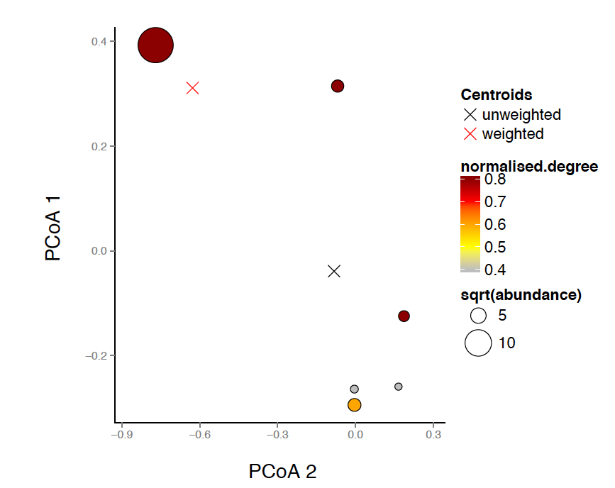

**Figure 1:**  Representation of pollinator species from one site, conserving only the two first axes of the PCoA used to calculate functional originality and uniqueness. Darker colours represent pollinators of higher normalised degree. The size of each point corresponds to the square root of pollinator abundances. When these abundances are accounted for, the location of the centroid shifts towards the more abundant species (red cross); when only presence-absence of pollinators are used, the centroid corresponds to the unweighted mean of species’ traits, and occupies a central position (black cross). As shown in Table 1a, the distances to the weighted centroid (i.e. pollinator weighted originality) are shorter for species with higher normalised degree, and their nearest neighbours (i.e. pollinator uniqueness) are further away than for species of lower normalised degree. We show in the S.I. (Appendix 2) that pollinator originality in the unweighted centroid is not significantly different for pollinators of higher or lower normalised degree.

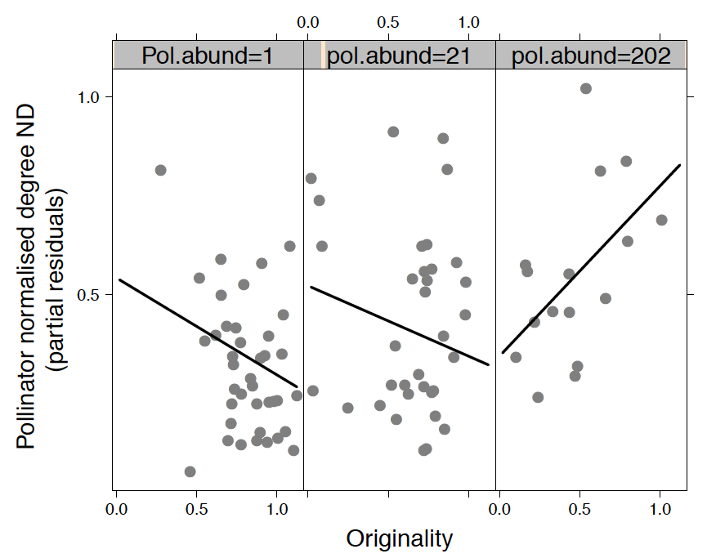

**Figure 2:** Partial residual plots from the pollinator model representing the effect of pollinator functional originality on its number of interactions (normalised degree, ND) for fixed values of pollinator abundances(for presentation, whereas in analyses abundance was treated as a continuous variate). In each panel, points correspond to partial residuals versus raw values of originality; pollinator abundance is fixed to the 10th, 50th and 90th quantiles (1, 21 and 202 respectively), while network size is kept constant at the median (45) to calculate the fitted values (lines). Residuals were taken from a model that included site as a random effect, to show relationships within sites.

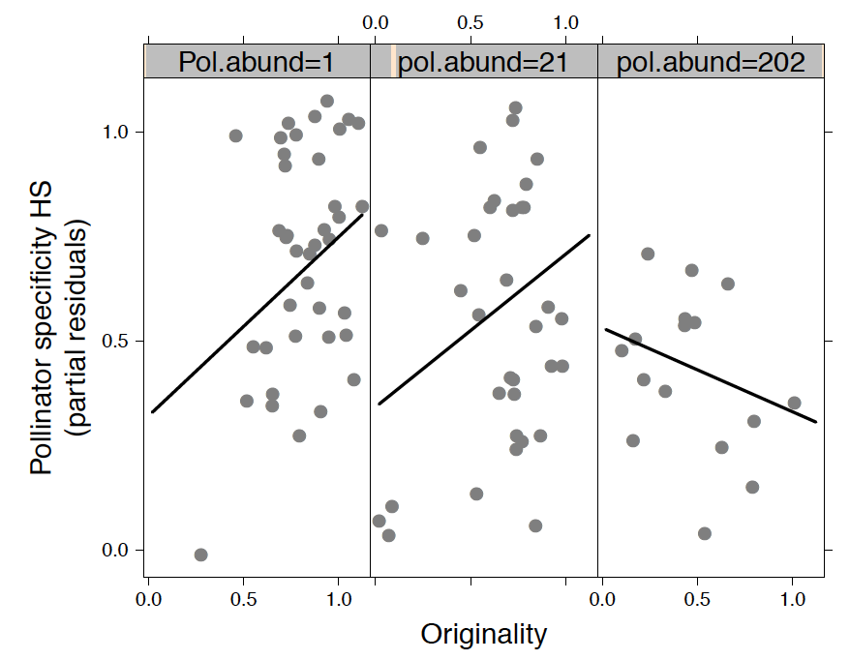

**Figure 3:** Partial residual plots from the pollinator model representing the effect of pollinator functional originality on specificity (HS) for fixed values of pollinator abundances. In each panel, points correspond to partial residuals versus raw values of originality; pollinator abundance is fixed to the same values as in Figure 1 to calculate the fitted values (lines). No other variables were included in the best-fitting models, except for site, which remained as a random effect.

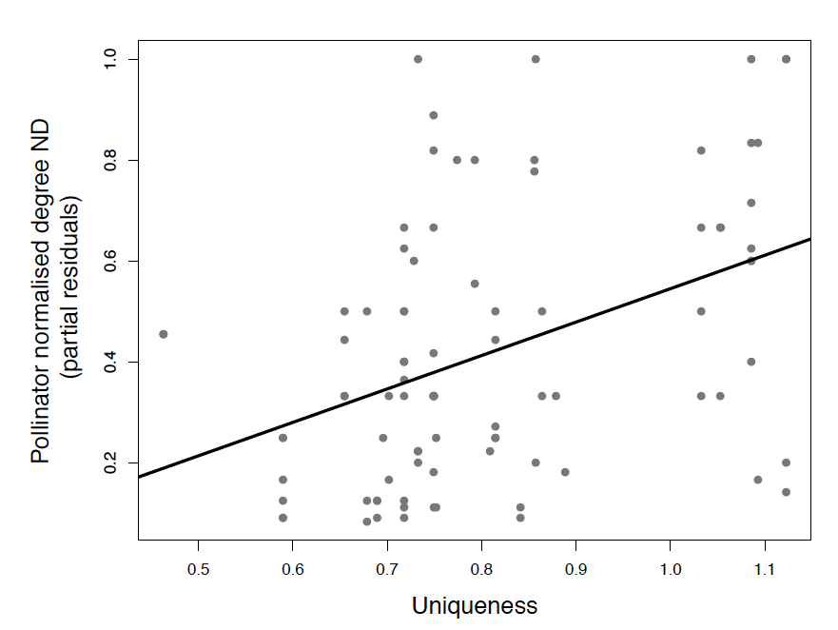

**Figure 4:** Partial residual plots from the pollinator model representing the effect of pollinator uniqueness (distance to the nearest neighbour) on its number of interactions (normalised degree, ND). Points correspond to raw values of pollinator uniqueness versus their partial residuals. The line represents the fitted values of the model accounting for the random effect of site.

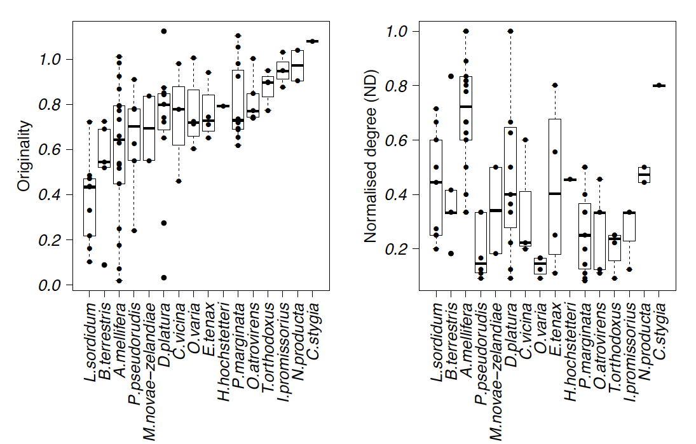

**Figure 5:** Variation in originality (left) and normalised degree (right) across sites according to pollinator identity. Raw values are shown to indicate the frequency of each species occurrences across sites. Species are ordered according to their increasing mean originality in both figures.